Motion Title | Framing the Medium to Long Term Response of the Church to Increasing Natural Disasters
Proposed by | Mr. Fe’iloakitau Kaho Tevi
Seconded by | Rev. Jacynthia Murphy; Venerable Sepiuta Hala’api’api

MOTION # 13

This General Synod / te Hīnota Whānui 2016 in its deliberation:

Mindful of the devastation caused by 2 category 5 tropical cyclones that hit 10 Pacific Island Countries in particular Vanuatu (TC PAM), Fiji (TC WINSTON) and Tonga (TC WINSTON);

Noting with sadness the loss of lives in Vanuatu (11 persons) and in Fiji (44 persons) resulting from the severity of tropical cyclones Winston and Pam;

Noting with deep gratitude the generosity of the people of Aotearoa New Zealand and other Pacific Island Countries to come to the immediate assistance of these 2 countries offering much needed emergency aid and development assistance;

Concerned about the continued assistance from the Church that rests mainly with the collection of clothes, kitchen items and immediate food rations;

Noting the leadership of Rev. Mike Hawke and the generous contributions of the parishes in Christchurch towards a 40ft container filled with building materials and tools for the Diocese of Vanuatu and the parishes affected by TC PAM on Efate, Vanuatu in 2015;

Cognizant of the dire need for this Church to develop a medium to longer term response to the increasing disasters focused on building the resilience and reducing the risk to the communities that are vulnerable to such extreme weather events;

Urged by the concluding points of the 2016 Tikanga Toru Youth Synod proposing that youth groups play a more proactive role in building up the resilience of local communities in the face of increased weather events;

This General Synod / te Hīnota Whānui 2016 therefore:
- Mandates the Anglican Mission Board to work with other relevant service providers of the Church to:
- Establish a clear resilience strategy that would strengthen the Anglican Church of Aoteraroa New Zealand and Polynesia’s response to any future natural disaster.
- Develop clear strategies linking the Anglican Church of Aoteraroa New Zealand and Polynesia with disaster relief agencies to enable a cadre of Church Community trainers who are then tasked in training the youth groups of the parishes in disaster preparedness.
- Develop a Diocesan Rapid Response Plan that would allow the Anglican Church of Aoteraroa New Zealand and Polynesia to respond in a timely and strategic manner to any community affected by a natural disaster in the Pacific Island Countries under its jurisdiction.
- Link into the Disaster Risk Reduction networks with a view to creating partnerships with other like-minded bodies involved in the area of jurisdiction of the Church.
- Create a conducive environment for longer term partnerships between parishes in New Zealand and those in the Diocese of Polynesia with the objective of developing longer term twinning parish partnerships on resilience and preparedness
- Invites AMB to consider this motion as a priority in its work plan for 2016-2017.
- Mandates GSSC to monitor the implementation of this motion in close collaboration with the AMB and other relevant partners and report back on its implementation at the General Synod / te Hīnota Whānui 2018.

RATIONALE
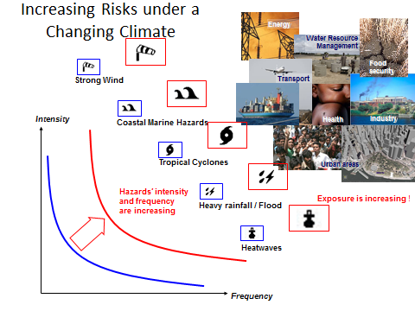
Resilient communities, resilient infrastructures and capacitated human resources of Pacific Island countries to handle disasters through all its phases will need to become a top priority for the Pacific Island Countries over the next 4 years.

A clear marked added value of the involvement of the 3 Tikanga Church in the periods before a disaster and from approximately 5-7 weeks after the disaster is based on the longer term presence of local actors on the ground as compared to humanitarian and disaster relief agencies that fly in and are out of the disaster zone within 2 weeks to a month of the disaster.

Recognizing the mark increase in severe weather patterns, the Synod of Diocese of Polynesia also adopted a motion to begin engagement with church communities in and around the Diocese of Polynesia to increase their resilience towards extreme weather. The rationale behind this motion was the fact that the jurisdiction of the Diocese of Polynesia covers Pacific Island Countries that are prone to tropical cyclones and other extreme weather. The implementation of this motion was being prepared when tropical cyclone Winston hit Fiji in February 2016, about 8 after the Diocesan Synod.
In order to be best prepared for the next disaster and in order to best respond to this above mentioned need, it is critical that the Anglican Church of Aotearoa New Zealand and Polynesia develops the appropriate programmatic priorities and sets its target to be ready to respond appropriately to disasters.
The recent 3 Tikanga Youth Synod in Wellington this year echoed the call from the youth representatives of the Diocese of Polynesia to use the youth groups in any future effort of the church to build greater resilience of the communities.

BACKGROUND
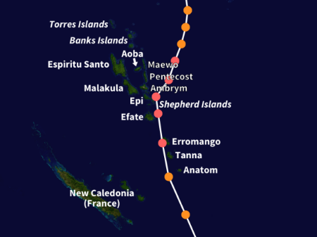
Severe Tropical Cyclone Pam of 2015 is regarded as one of the worst natural disasters in the history of Vanuatu. The storm's impacts were also felt, albeit to a lesser extent, to other islands in the South Pacific, most notably the Solomon Islands, Tuvalu, and New Zealand. TC Pam is the second most intense storm of the South Pacific Ocean according to pressure and is also the third most intense storm in the Southern Hemisphere by the same metric. In addition, Pam had the highest 10-minute sustained wind speed of any South Pacific tropical with wind gusts reaching as high as 320 km/h. Thousands of homes, schools and buildings were damaged or destroyed, with an estimated 33,000 people displaced as a result.

In another occurrence no less than a year after TC Pam, the Fijian Islands, and Tonga bore the brunt of tropical Cyclone Winston in early 2016. It is envisaged that the cyclone seasons would be increasingly active in the coming years. The likely increase in the severity and frequency of category 5 cyclones would place greater importance in the preparation of the communities and the church structures to handle natural disasters of any magnitude.

An estimated 24,000 homes were damaged or destroyed, leaving approximately 120,000 people in need of immediate shelter assistance. Preliminary estimates in the storm's immediate aftermath pegged damage FJ$1 billion (US$460 million). Surveys through 8 March indicated total damage to be at least FJ$348.3 million (US$165.3 million).

Assessed damage includes
- FJ$185.2 million (US$87.9 million) to agriculture,
- FJ$50.2 million (US$23.8 million) to education,
- FJ$7 million (US$3.3 million) to roads, and
- FJ$4.61 million (US$2.16 million) to health.
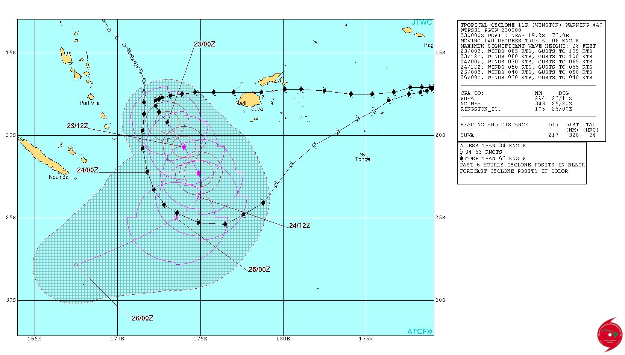
Impacting Tonga twice within the span of a few days, Winston caused significant damage across northern Tonga. Approximately 2,500 people sought refuge in shelters. The first passage of the storm resulted in mostly crop damage while the second brought greater structural damage. At least 10 homes were destroyed and 200 more were damaged Agriculture sustained significant damage, with 85–95 percent of the banana crop and most of the vanilla crop on Vava'u lost. Winston also affected Niue on 16 February; the FMS also issued tropical cyclone and damaging heavy swell warnings for the island nation.

Aftermath
- Cyclone Winston's devastating impact across Fiji rendered tens of thousands homeless and prompted a major international humanitarian response.
- An estimated 350,000 people (40 percent of the nation's population) were moderately or severely affected by the storm, including 120,000 children.
- Approximately 250,000 people required water, sanitation, and hygiene (WASH) assistance due to power outages and damaged infrastructures.
- Through the evening of 26 February, approximately 62,000 people were housed evacuation centres across the country, primarily in the Western Division. This number steadily fell to 29,237 by 4 March, though thousands more stayed with relatives.
- The Governments of Australia, France, and New Zealand quickly responded with a large-scale relief effort within days of the storm's passage. Several other nations provided donations, supplies and funds, as did various international organizations.

https://en.wikipedia.org/wiki/Cyclone_Winston

